

Department: Computer Science, Air University

Submitted by: Arooba Shehzadi
Reg ID: 231678
Course: Visual Programming Lab
Submitted To: Miss Sara Ibrahim
Submission Date: March 25, 2025

Code:
List Task
Code:
ItemService.cs
public class ItemService
{
private List<string> items = new List<string>();

public List<string> GetItems() => items;

public void AddItem(string item)
{
if (!string.IsNullOrWhiteSpace(item))
{
items.Add(item);
}
}
public void RemoveItems(string item)
{
items.Remove(item);
}
}

Item-Manager.razor
@page "/Item-manager"
@rendermode InteractiveServer
@inject ItemService Itemservice

<h3>Item Manager</h3>

<div>
<input type="text" @bind="newItem" placeholder="Enter the Item" />
<button @onclick="AddItem">Add Item</button>

</div>

<ul>
@foreach (var item in Itemservice.GetItems())
{
<li>
@item
<button @onclick="() => RemoveItem(item)"> Delete </button>
</li>
}
</ul>
@code {
private string newItem = "";
private void AddItem()
{
Itemservice.AddItem(newItem);
newItem = "";
}

private void RemoveItem(string item)
{
Itemservice.RemoveItems(item);
}

}

Output:
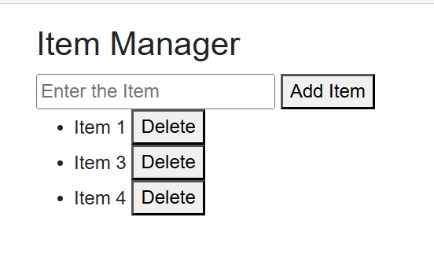
Lab Tasks:
Task 1:
Salary Calculation Service
Code:
SalaryCalculationService.cs
// SalaryCalculationService.cs
public class SalaryCalculationService
{
public decimal TaxRate { get; set; } = 0.10m; // Default 10%
public decimal InsuranceRate { get; set; } = 0.05m; // Default 5%
public decimal BonusRate { get; set; } = 0.08m; // Default 8%
public decimal BenefitRate { get; set; } = 0.03m; // Default 3%

public (decimal Deductions, decimal Allowances, decimal NetSalary) CalculateSalary(decimal basicSalary)
{
decimal tax = basicSalary * TaxRate;
decimal insurance = basicSalary * InsuranceRate;
decimal deductions = tax + insurance;

decimal bonus = basicSalary * BonusRate;
decimal benefits = basicSalary * BenefitRate;
decimal allowances = bonus + benefits;

decimal netSalary = basicSalary - deductions + allowances;

return (deductions, allowances, netSalary);
}
}

SalaryCalculation.razor
@page "/salary-calculator"
@inject SalaryCalculationService SalaryService
@rendermode InteractiveServer
<h3>Salary Calculator</h3>

<div>
<label>Enter Basic Salary: </label>
<input type="number" @bind="BasicSalary" />
</div>

<button @onclick="Calculate">Calculate Salary</button>

<div>
<label>Deductions: </label>
<span>@Deductions.ToString("C")</span>
</div>

<div>
<label>Allowances: </label>
<span>@Allowances.ToString("C")</span>
</div>

<div>
<label>Net Salary: </label>
<span>@NetSalary.ToString("C")</span>
</div>

<div>
<h4>Salary Description:</h4>
<p>@SalaryDescription</p>
</div>

@code {
private decimal BasicSalary { get; set; }
private decimal Deductions { get; set; }
private decimal Allowances { get; set; }
private decimal NetSalary { get; set; }
private string SalaryDescription { get; set; } = "Enter a salary and click calculate to see details.";

private void Calculate()
{
(Deductions, Allowances, NetSalary) = SalaryService.CalculateSalary(BasicSalary);
SalaryDescription = $"With a basic salary of {BasicSalary:C}, you have deductions of {Deductions:C}, allowances of {Allowances:C}, and a net salary of {NetSalary:C}.";
StateHasChanged();
}
}

Output:
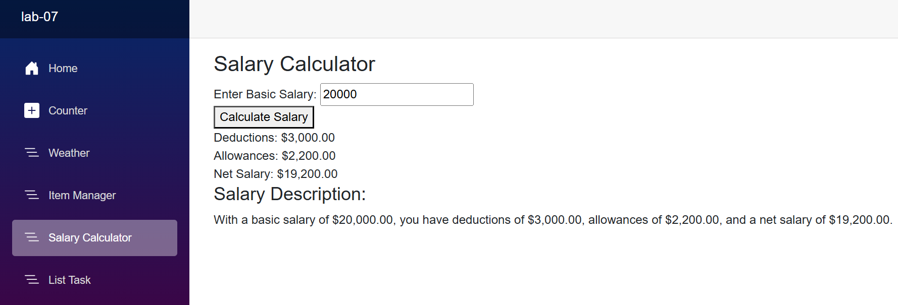

Task 2:
List Tasks
Code:
ElementService.cs
public class ElementService
{
private List<string> Elements { get; set; } = new();

public List<string> GetElements(string searchTerm = "")
{
return string.IsNullOrWhiteSpace(searchTerm)
? Elements
: Elements.Where(e => e.Contains(searchTerm, StringComparison.OrdinalIgnoreCase)).ToList();
}

public void AddElement(string element)
{
if (!string.IsNullOrWhiteSpace(element) && !Elements.Contains(element))
{
Elements.Add(element);
}
}

public void EditElement(string oldElement, string newElement)
{
int index = Elements.IndexOf(oldElement);
if (index != -1 && !string.IsNullOrWhiteSpace(newElement))
{
Elements[index] = newElement;
}
}

public void DeleteElement(string element)
{
Elements.Remove(element);
}
}

ElementManager.razor
@page "/element-manager"
@inject ElementService ElementService
@rendermode InteractiveServer
<h3>Element Manager</h3>

<input type="text" @bind="NewElement" placeholder="Enter new element" />
<button @onclick="AddElement">Add</button>

<input type="text" @bind="SearchTerm" placeholder="Search elements" />
<button @onclick="SearchElements">Search</button>

<ul>
@foreach (var element in FilteredElements)
{
<li>
@if (EditingElement == element)
{
<input type="text" @bind="EditedElement" />
<button @onclick="() => SaveEdit(element)">Save</button>
<button @onclick="CancelEdit">Cancel</button>
}
else
{
@element
<button @onclick="() => StartEdit(element)">Edit</button>
<button @onclick="() => DeleteElement(element)">Delete</button>
}
</li>
}
</ul>

@code {
private string NewElement { get; set; } = "";
private string SearchTerm { get; set; } = "";
private string EditedElement { get; set; } = "";
private string EditingElement { get; set; } = "";
private List<string> FilteredElements = new();

protected override void OnInitialized()
{
FilteredElements = ElementService.GetElements();
}

private void AddElement()
{
ElementService.AddElement(NewElement);
NewElement = "";
RefreshList();
}

private void StartEdit(string element)
{
EditingElement = element;
EditedElement = element;
}

private void SaveEdit(string oldElement)
{
ElementService.EditElement(oldElement, EditedElement);
EditingElement = "";
EditedElement = "";
RefreshList();
}

private void CancelEdit()
{
EditingElement = "";
EditedElement = "";
}

private void DeleteElement(string element)
{
ElementService.DeleteElement(element);
RefreshList();
}

private void SearchElements()
{
RefreshList();
}

private void RefreshList()
{
FilteredElements = ElementService.GetElements(SearchTerm);
}
}

Output:
